Sweet Crust Bakery

Scenario Overview:

Sweet Crust Bakery Assistant is a customer-service chatbot for a small bakery. It helps users browse the menu, ask about hours and allergens, place pickup orders, request custom cakes, check order status, and get contact information. The bot supports slot filling for bakery orders and handles digressions such as answering store hours mid-order before returning to the unfinished order flow.

Intents:

For our chatbot, we have 10 intents currently. These intents range from greeting customers to handling various forms of queries such as making purchases,reservations, or asking questions. In this section, we will list our intents with their intended purposes-

Intent | Purpose
#cancel_order | The purpose of this intent is to help customers cancel their orders.
#allergens | The purpose of this intent is to cater to customers' unique allergy needs. When customers ask about potential allergens or if there are alternative options for their food restrictions, this intent dictates how to respond to those queries.
#confirm_no | Used when the user rejects, cancels, or corrects a prompted question/next step
#confirm_yes | Used when the user confirms, agrees with a prompted question/next step
#contact | Shares contact methods like phone number, email, website, or “how do I reach you”.
#goodbye | Handles ending conversations politely.
#greeting | Handles salutations and starts the conversation in a polite and friendly manner.
#hours | Answers questions about business hours/open/close times and days open.
#human_agent | Routes the user to a real person/manager/agent when requested.
#location | Provides store address, directions, or where the shop is located.
#menu | Helps users browse what the store sell / what items are available.
#order | Starts the ordering flow (placing a new order / buying something).
#prices | Handles “how much is…” questions and requests for price lists/costs.
#specials | Answers questions about deals, discounts, promotions, or “today’s specials”.
#thank_you | Responds to appreciation and closes the loop politely (e.g., “Thanks”, “Much appreciated”).
#help | Gives user a list of topics the chatbot can help with

Entities:
1) bakery_item
Purpose: capture what the customer wants to buy/order.
Example values (with synonyms): bread (“loaf”, “sourdough”, “baguette”), cake (“layer cake”, “torte”), cupcake (“cup cake”), cookie (“biscuit”), croissant (“almond croissant”), donut (“doughnut”), pie (“apple pie”), etc.
2) quantity
Purpose: capture how many items the customer wants.
Example values (with synonyms): one (“1”, “single”), half dozen (“6”, “six”), dozen (“12”, “twelve”), two dozen (“24”).
3) flavor
Purpose: capture flavor preference for items/cakes.
Example values (with synonyms): chocolate (“choco”, “dark chocolate”), vanilla (“vanilla bean”), strawberry (“fresh strawberry”), red velvet, caramel (“toffee”), coffee (“mocha”, “espresso”), etc.
4) size
Purpose: capture size requests (used in custom cake flow; also general sizing).
Example values (with synonyms): small (“mini”), medium (“regular”), large (“big”), extra large (“XL”).
5) dietary
Purpose: capture dietary/allergy needs.
Example values (with synonyms): gluten free (“GF”), vegan (“plant-based”), sugar free, nut free, dairy free etc.

System entity:
@sys-date
Captures the pickup date for an order. This system entity allows the chatbot to automatically recognize natural language dates such as “tomorrow”, “Friday”, or “December 12”.
@sys-time
Captures the time a customer wants to pick up their order. Example: “3 pm”, “noon”, “I will pick it up at 4 pm” etc.

Slot flow:

The main slot-based conversation in the chatbot is the order flow. When the user expresses the intent to place an order, the chatbot collects the key details needed to complete a bakery pickup request.

How the flow works:
- Start the flow - when the user triggers the #order intent, the chatbot begins the ordering process.
- Collect item to be ordered- The bot then prompts the user to put in the item they wish to order. If it does not match any of the @bakery_items entities, then it reprompts the user to put in a valid item. If the user digresses, then it answers the questions and goes back to the flow and reprompts again.
- Collect flavor - The bot then prompts the user to put in the item flavor they wish to order. If it does not match any of the @flavor entities, then it reprompts the user to put in a valid item. If the user digresses, then it answers the questions and goes back to the flow and reprompts again.
- Collect quantity- After successfully putting in a valid item, the bot will now prompt the user to put in how many of the item they wish to order. If response is valid, then the bot stores it and continues.
- Collect pickup date - Bot now prompts user for a date for pickup.Examples of valid inputs could be “tomorrow”, “next Monday”, “March 12th” etc. If user inputs a valid date then bot will store it and continue with the flow.
- Collect time - Finally, bot will prompt for a pickup time. If user inputs a valid response then the bot will respond with an order summary.
- Confirmation - Once the user inputs all responses correctly the bot will show an order summary and ask the user for confirmation of the order. If the user responds yes, then the flow is complete. If user responds no, then the flow begins from step 1 again.
Example Bot confirmation:
Here’s what I captured:
Item: cupcakes
Quantity: one dozen
Pickup Date: Friday
Pickup Time: 3 PM
Is that correct?

Context Variable:

context.current_flow
Tracks whether the user is in ordering, custom_cake, or none.
context.order_summary
Stores the collected order details for later confirmation.
context.last_intent
Useful for recovery/fallback and documenting conversation control.
context.escalation_requested
Set when the user asks for a human.

Digression:

The chatbot supports digressions that allow users to temporarily leave the main ordering flow to ask related questions. This improves usability by allowing users to obtain additional information without losing progress in their current task.

- Hours Digression
This digression occurs when users ask the bot about the store hours while in the middle of ordering. The digression is triggered by the intents #hours and the context where the order flow is in progress. If the customer asks about the hours, then the bot will give them the store hours and then return back to the order flow, prompting the user again to continue ordering.
- Specials Digression
This digression occurs when users ask the bot about the special sales while in the middle of ordering. The digression is triggered by the intents #special and the context where the order flow is in progress. If the customer asks about the special sales, then the bot will give them the special items on sale and then return back to the order flow, prompting the user again to continue ordering.
- Allergy Digression
This digression occurs when users ask the bot about the store’s allergy policies while in the middle of ordering. The digression is triggered by the intents #allergy and the context where the order flow is in progress. If the customer asks about the allergens, then the bot will give them the allergies and dietary needs the store caters to, and what items are available for each before returning to the order flow, prompting the user again to continue ordering.

Conversation Transcripts:

- Order Flow-

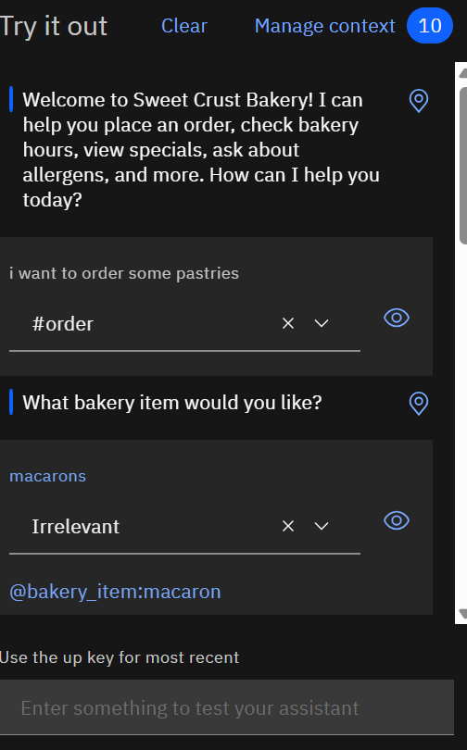  1. | 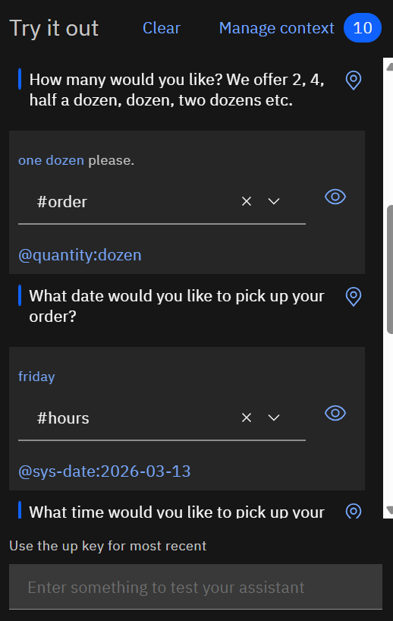  2.
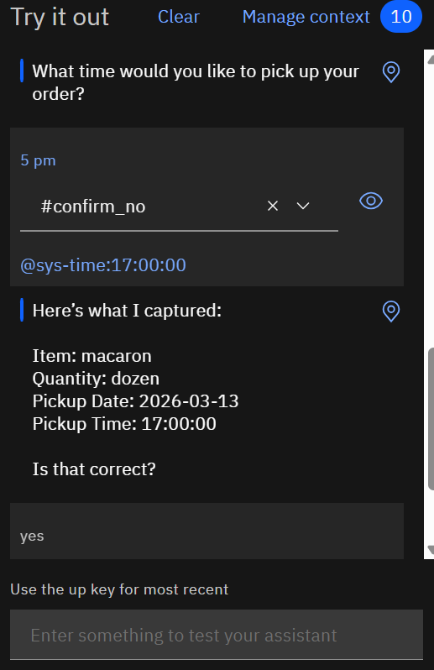  3. | 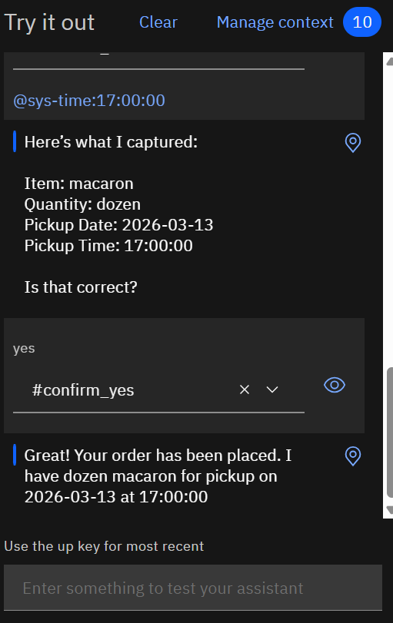  4.

- Digression:

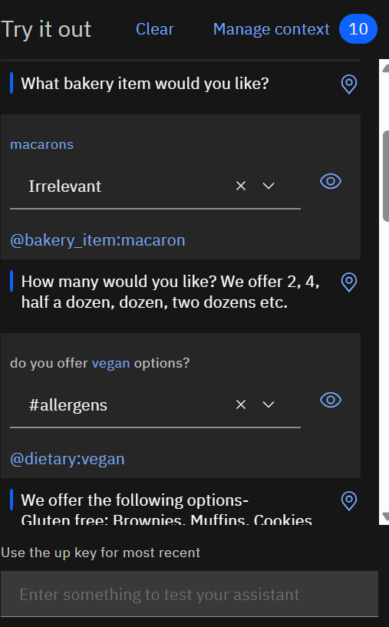
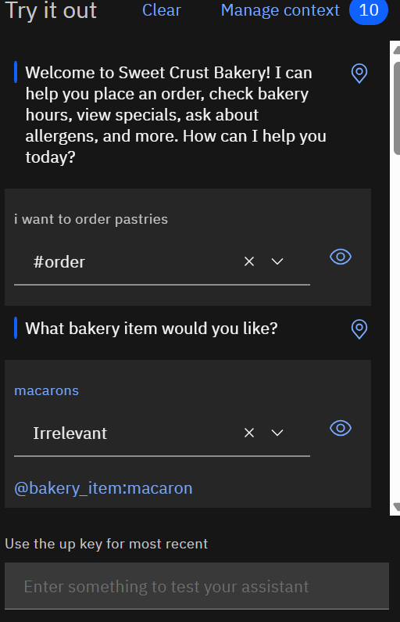
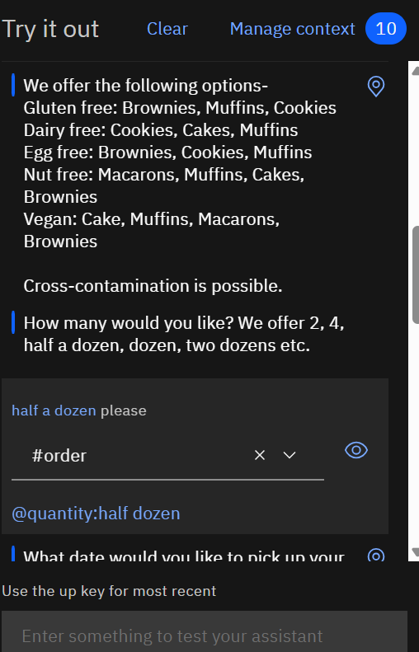
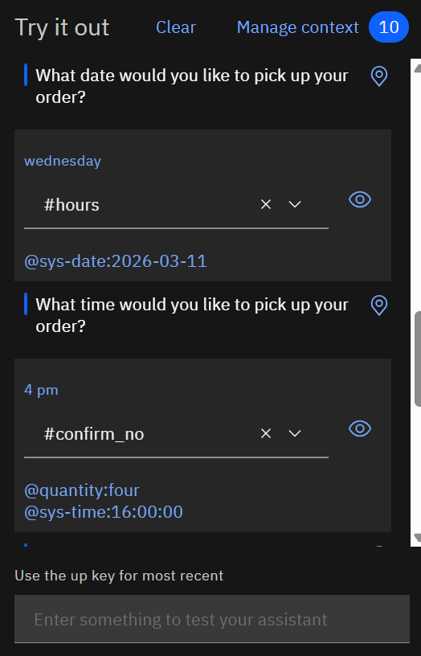

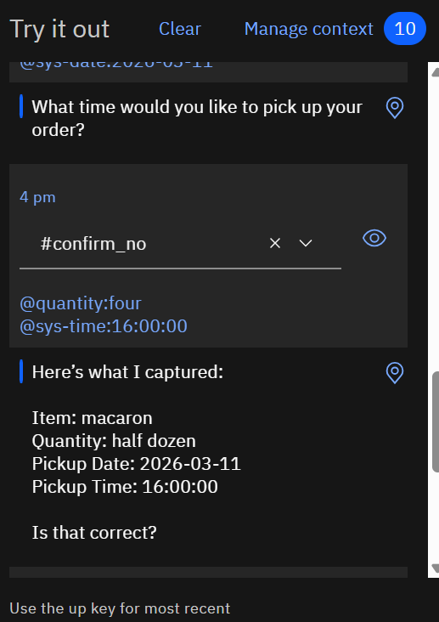

- Failure Case:
